Project Proposal
Language Learning Platform
Student Name: Guilherme Junio da Silveira
Student Number: 23413271

Objectives
This project aims to build a web-based platform to help people learn and remember vocabulary in a new language. The idea is to let students log in, choose how difficult they want the questions to be, and take short quizzes based on flashcards.
What makes this platform different is that it keeps track of how each student performs and adjusts the repetitions of questions based on what they find more difficult, using a method called spaced repetition. The goal is to improve memory through a smarter review system and give students feedback about their progress. This type of tool could be especially useful for language learners who want to study at their own pace and track their improvement over time.

Background
There are many websites and apps that help people study with flashcards, but most of them show the same cards again and again, without considering what each person finds hard or easy. This project will solve that by showing harder flashcards more often and easier ones less frequently, based on how the student performs.
The platform will also have a progress section where students can see how they are doing – for example, how many questions they have answered, what topics they struggle with, and how their accuracy improves over time. This helps them understand where to focus more and how much they have improved. The main target audience is students who are learning a new language and want a simple, personalised way to study vocabulary and sentences.
This approach builds on common learning tools but focus on adaptative difficulty and personalisation, which is often missing in basic flashcards apps. The idea is to combine simplicity with intelligent feedback and better long term learning outcomes.

Technical Approach
The system will be built using Java and Spring Boot for the backend, along with MySQL database to store information such as user accounts, flashcards, quizzes, and scores. The frontend will be a simple and responsive website using basic web technologies (HTML, CSS, Bootstrap), keeping the interface clean and user-friendly without overcomplicating the design.
Main features will include user login, a quiz system based on flashcards, tracking student performance, and adapting the appearance of flashcards based on quiz results. A test-driven approach will be used during development to ensure that the main functions work properly, and the code will be well documented.
In the first phase of development, system requirements will be outlined in more detail, and a brief review of strategies such as spaced repetition will help inform the logic behind quiz generation and flashcard ordering.

Special resources required
There are no special resources needed for this project. All required tools, such as an IDE, a database tool, and a code editor, are available for free. A few test users will be asked to try the system and give feedback later in the project.

Project Plan
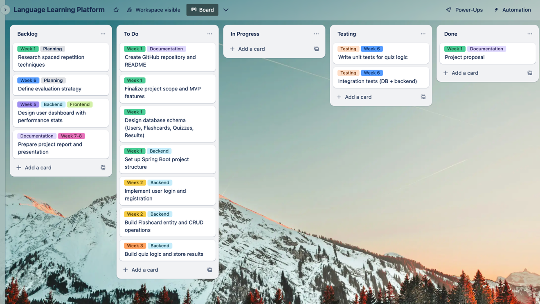
The image above shows how the project is planned using Trello. The tasks are organised into columns such as Backlog, To Do, Testing, and Done. Each task also has coloured labels to show which week it will be worked on and what type of task it is (like backend, documentation, or testing). This helps keep the project organised and makes it easy to see what needs to be done and when. Tasks are also grouped according to development stages such as setup, core features, testing, and documentation, helping to keep each week focused and manageable.

Evaluation
The system will be tested in different ways to make sure it works well. This includes testing small parts of the code (unit testing), checking how the website and database work together (integration testing), and testing how users interact with the platform.
Some students will also be asked to try the system and answer a few questions about their experience. The project will be considered successful if students are able to log in, take quizzes, see their progress, and if the system correctly adapts flashcard repetition based on their performance.

